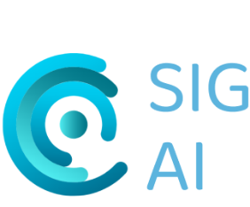

Student Research Symposium on

Artificial Intelligence

Sponsored by the AI-SIG and the European Chapter

5th June 2023, 2-4PM UK time | Virtual | Register at https://rb.gy/iz6ti by 1st June 2023

AGENDA (to be confirmed)

Introduction
Session 1 [Moderated by Andrew Cox]

Jiaxin An (The University of Texas at Austin) - Conversational agents for older adults’ health: a systematic literature review

Indra Mckie (University of Technology, Sydney, Australia) - Co-experiencing conversational AI: An ethnographic exploration of individual and collaborative use of voice assistants

Öykü Işıl Turhan (Hacettepe University, Turkey) - Artificial Intelligence Literacy
Break (10 minutes)
Session 2 [Moderated by Yuhua Wang]

Fauziyah Nihinlolawa Adenekan et al. (Babcock University, Nigeria) - AI application in libraries, archives and information environments

Nicole S. Delellis (University of Western Ontario, Canada) - Coverage of ChatGPT in Media Organizations

Alex Mayhew (University of Western Ontario, Canada) - Technological Forecasting: An Information Science Perspective on the Future of AI
Best presentation award voting and conclusion

